**Mapping Disparate Risk: A Comparative Geospatial Analysis of Disposal Well-Induced Seismicity and Social Vulnerability in Oklahoma and Ohio**

**Introduction**

Earthquakes are typically considered natural geological hazards, but since 2008, seismic activity across the Central and Eastern United States (CEUS) has risen sharply due to human activity. This increase has been directly tied to industrial practices, particularly the underground injection of wastewater produced during oil and gas extraction (Ellsworth, 2013; Jones & Rowan, 2023). Both hydraulic fracturing and conventional drilling generate large volumes of brine and wastewater, which are commonly disposed of in deep Class II wells (Jones & Rowan, 2023). The scientific consensus is that sustained, high-volume wastewater injection is the primary driver of the recent surge in earthquakes (Keranen et al., 2014; Weingarten et al., 2015; Zhai et al., 2021).

The physical mechanism behind this phenomenon is the increase in pore fluid pressure, which reduces the effective normal stress on pre-existing faults. This reduction allows faults to slip, releasing stored tectonic strain energy as earthquakes (Jones & Rowan, 2023; Zhai et al., 2021). Before 2008, the CEUS averaged fewer than 25 earthquakes of magnitude 3.0 or greater annually. By 2015, this number peaked at 1,010 events (Jones & Rowan, 2023; Cochran et al., 2024). Even after regulatory measures were introduced, seismicity rates remain elevated compared to historical levels (Jones & Rowan, 2023). This heightened hazard threatens infrastructure and increases public anxiety in communities historically unfamiliar with earthquake risk (Ellsworth, 2013).

The guiding geographic question for this project is: **Where do the greatest overlaps exist between induced earthquake hazards and socially vulnerable populations in the United States?**. To answer this, the study compares Oklahoma and Ohio, two states that represent distinct seismicity regimes. Oklahoma exemplifies basin-wide, high-volume hydraulic connectivity (Keranen et al., 2014), while Ohio demonstrates localized pore pressure diffusion (PPD) causality (Kim, 2013). By quantifying the proximity of earthquakes to disposal wells and overlaying these hazards with the Social Vulnerability Index (SVI), the research highlights inequities in exposure. This evidence is crucial for designing targeted hazard mitigation strategies.

The intended audience includes the U.S. Geological Survey (USGS), Centers for Disease Control and Prevention (CDC), state geological surveys, and local emergency management agencies. These organizations can use the findings to identify high-risk areas, prioritize seismic monitoring, and strengthen community preparedness. The ultimate goal is to provide geospatial evidence that supports policies preventing hydraulic connectivity with the crystalline basement, which is highly seismogenic (Hincks et al., 2018).

**Methods**

**Data**

This study integrated multiple geospatial datasets to capture seismic activity, disposal well operations, and socioeconomic vulnerability. Each dataset was carefully selected to ensure methodological consistency across Ohio and Oklahoma.

1. **Earthquake Data**
   * **Name:** EQ_OH_Permanent and EQ_OK_Permanent
   * **Source:** U.S. Geological Survey (USGS) Earthquake Catalog
   * **Coordinate System:** WGS84 (EPSG:4326)
   * **Description:** Point feature classes documenting earthquake events, including magnitude, depth, and geographic location. Each dataset was clipped to state boundaries to ensure spatial relevance (Seismic Risk Flowchart, n.d.).
2. **Disposal Wells (Injection Sites)**
   * **Name:** Injection_Wells_OK and DisposalWells_OH.
   * **Source:** Oklahoma Corporation Commission (OCC) and Ohio Department of Natural Resources (ODNR).
   * **Coordinate System:** WGS84 (EPSG:4326).
   * **Description:** Point data representing Class II disposal wells (Class IID), including operational attributes such as injection volume (barrels) and pressure (psi). These wells are distinct from enhanced recovery wells (Class IIR), which inject smaller volumes and pose lower seismic risk (Disposal Wells Analysis,).
3. **Social Vulnerability Index (SVI)**
   * **Name:** SVI.
   * **Source:** CDC/ATSDR Social Vulnerability Index.
   * **Coordinate System:** NAD83, converted to WGS84 for consistency.
   * **Description:** Census tract‑level socioeconomic data, including indicators such as poverty and minority status. Each tract is ranked nationally in terms of vulnerability, providing a standardized measure of social risk.

**Analysis**

The methodology relied heavily on vector‑based GIS techniques, particularly spatial buffering and attribute queries, to measure how close earthquake events were to disposal well infrastructure. To ensure consistency across states, the workflow was standardized and limited exclusively to active Class II disposal wells, since these are the operations most strongly associated with induced seismicity (Disposal Wells Analysis, n.d.).

**Step 1: Data Filtering and Normalization**

The first stage of data preparation involved filtering the well layers to retain only active disposal wells. In Ohio, this meant selecting wells coded as WELL_TYP = 'SW_R', with comparable codes applied in Oklahoma. This filtering was necessary to focus on the subset of wells scientifically confirmed as the primary drivers of induced seismicity (Disposal Wells Analysis, n.d.; Zhai et al., 2021). After filtering, 230 active disposal wells were identified in Ohio and 3,830 in Oklahoma (Disposal Wells Analysis, n.d.).

For normalization, raw counts of disposal wells and earthquakes were converted into rates per 10,000 residents. This adjustment allowed for fair comparisons across populations, ensuring that seismic risk was measured in terms of exposure rather than absolute counts (Cartographic Principles, n.d.).

**Step 2: Proximity Analysis Using Geodesic Buffering**

To delineate zones of seismic influence, geodesic buffers were created around disposal wells (Vector Analysis Lecture, 2025).

1. **Buffer Parameters:** Rings were generated at distances of 5 km, 15 km, 25 km, and 45 km to establish clear gradients of proximity (Seismic Risk Flowchart, n.d.). The geodesic method was chosen because all datasets were standardized to the WGS 1984 Geographic Coordinate System, which requires measuring distances along the Earth’s curvature for accuracy.
2. **Layer Preparation:** The buffer polygons for each state were clipped using the respective state boundary polygons. This ensured that the analysis was geographically constrained to each state, eliminating any influence from neighboring states.

**Step 3: Stratified Earthquake Selection and Summary**

Earthquake data from the EQ_Permanent layers were divided into subsets based on magnitude and depth, reflecting both policy relevance and scientific hypotheses:

* **Magnitude thresholds:** Moderate (M ≥ 3.0) and strong (M ≥ 4.0) events.
* **Depth thresholds:** Shallow (< 5 km) and intermediate (5–15 km) events.

The Spatial Join tool was then applied to identify which earthquakes intersected with the clipped buffer zones. This process isolated specific subsets (e.g., EQ_Shallow) that occurred within defined distances, such as 25 km, from disposal wells. The resulting spatial distributions are quantified in **Table 1**.

**Step 4: Statistical Summarization and Comparative Output**

For each spatial subset (e.g., EQ_M3plus_OH_within_25km), three key statistics were calculated and compiled into a comparative matrix **(Table 1)**:

* **Frequency (Count):** Total number of events.
* **Mean Magnitude (MEAN_mag):** Average earthquake strength, indicating intensity gradients.
* **Mean Depth (MEAN_depth):** Average focal depth, reflecting surface risk and proximity to injection zones.

**Supplemental Bivariate Mapping (Oklahoma)**

In addition to the buffer analysis, a bivariate mapping technique was applied in Oklahoma to visualize injection intensity. In this map, well symbol size represented barrels injected (bbls), while symbol color represented injection pressure (psi). This visualization highlighted the 584 high‑volume wells—defined as those exceeding 10,000 barrels and 1,000 psi—and illustrated how these operations concentrated seismic risk (High‑Volume Wells).

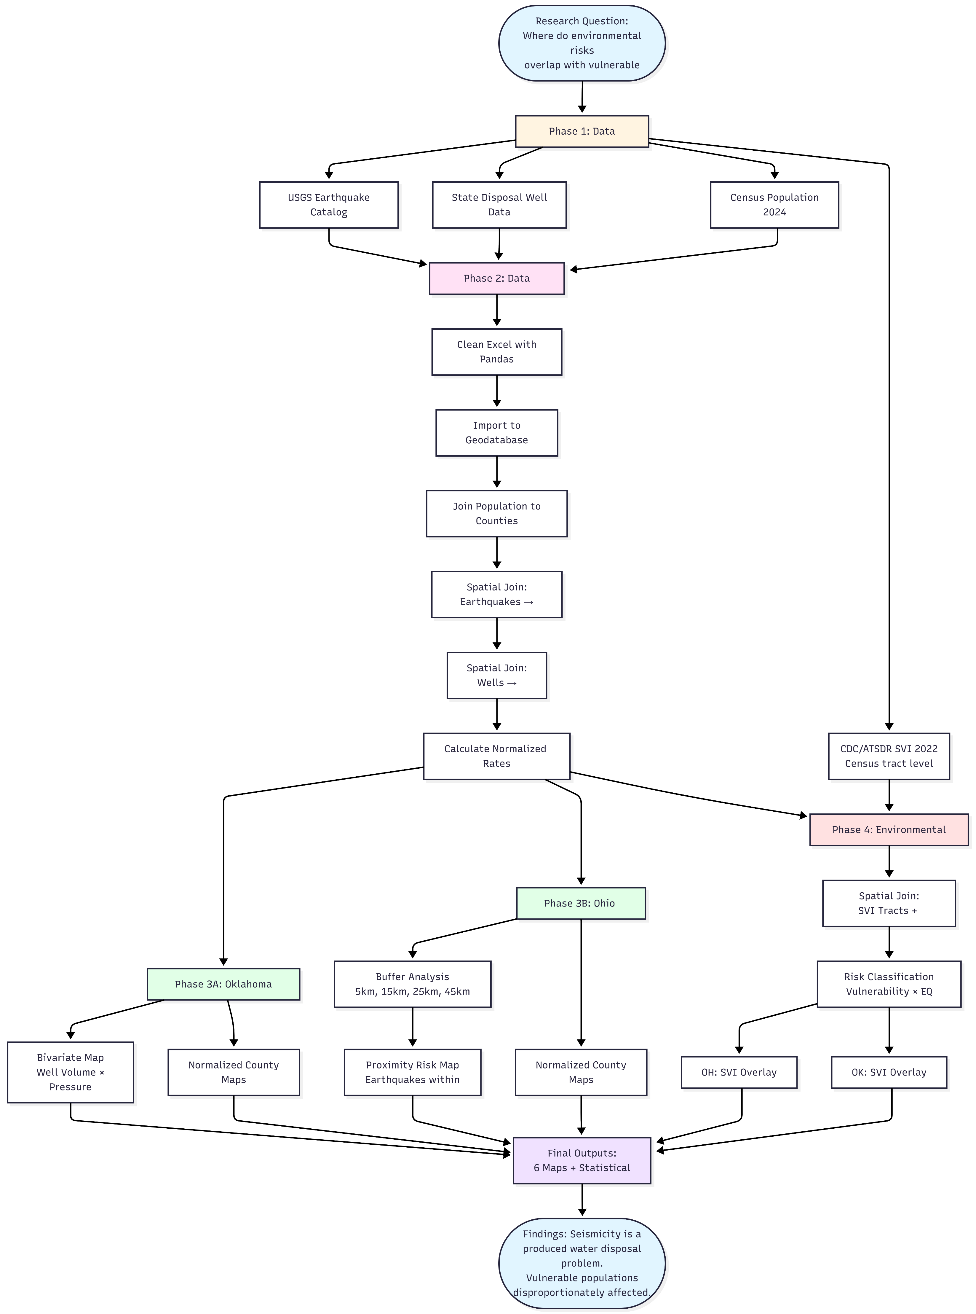

**Figure 1: Environmental Risk Flow Chart**

**Results & Discussion**

The analysis demonstrates that wastewater disposal is the definitive human‑driven cause of seismicity in both Ohio and Oklahoma. However, the way the hazard unfolds differs, reflecting variations in operational scale and geological response (Zhou et al., 2024). Oklahoma illustrates a large‑scale, basin‑wide crisis driven by high‑volume injection, while Ohio represents a smaller, proximity‑based hazard (Kim, 2013). By combining spatial metrics such as buffer distances with earthquake attributes like depth and magnitude, the study enables a direct comparison of risk exposure between the two states.

**3.1 Comparative Analysis of Injection Infrastructure and Seismic Scale**

The most notable finding is the stark difference in both the scale of injection activity and the frequency of earthquakes between Ohio and Oklahoma (Pollyea et al., 2019). The analysis confirmed that restricting the dataset to active Class II disposal wells was the most relevant approach for studying induced seismicity (Disposal Wells Analysis, n.d.).

Oklahoma operated roughly 3,830 disposal wells, creating massive fluid movement that facilitated widespread pressure diffusion (Disposal Wells Analysis, n.d.; Keranen et al., 2014). In contrast, Ohio maintained only about 230 active disposal wells, resulting in a much more localized seismic hazard (Disposal Wells Analysis, n.d.).

This disparity is clearly illustrated in the normalized choropleth maps:

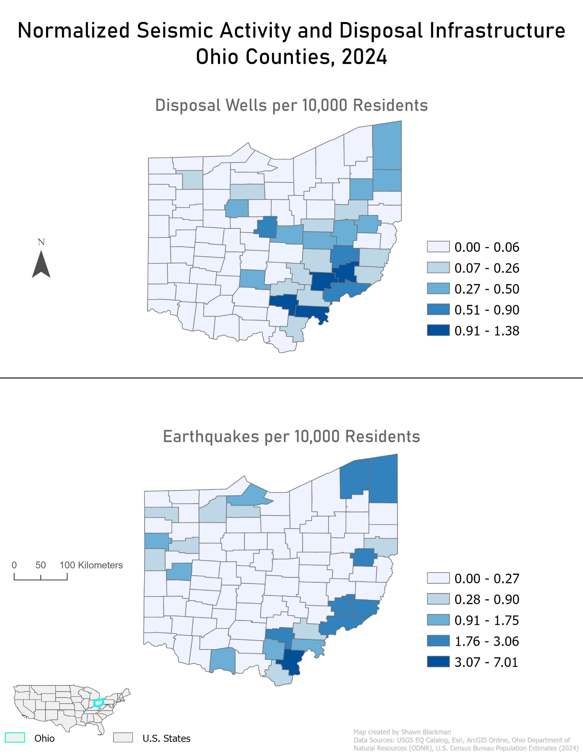

**Figure 2: Normalized Seismic Activity and Disposal Infrastructure Ohio Counties 2024**

Seismic activity and well density are concentrated in the eastern counties. Normalized disposal well density peaks between 0.91 and 1.38 per 10,000 residents, coinciding with earthquake rates of 3.07–7.01 events per 10,000 residents. This supports the interpretation of episodic, localized induced events (Kim, 2013).

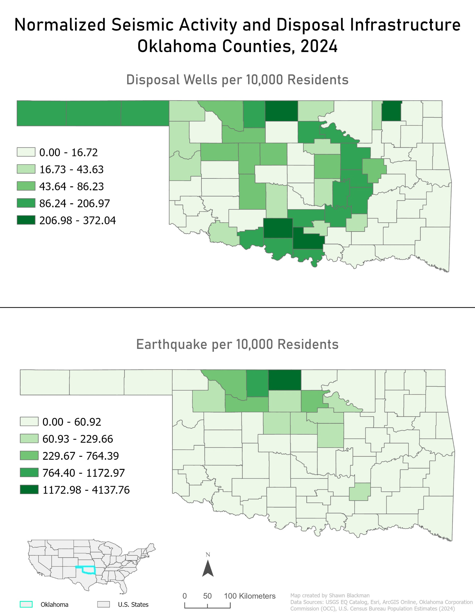

**Figure 3: Normalized Seismic Activity and Disposal Infrastructure Oklahoma Counties 2024**

Earthquake rates and well counts are dramatically higher. Disposal well density reaches 206.98–372.04 per 10,000 residents in core areas, correlating with maximum earthquake rates of 1,172.98–4,137.76 events per 10,000 residents. This reflects the expansive pressure field created by deep injection into the Arbuckle Group (Keranen et al., 2014).

**3.2 Bivariate Analysis of Injection Intensity (Oklahoma)**

To identify the highest‑risk operations, the dataset was filtered to highlight wells with both high volume and high pressure, rather than considering these parameters separately (High‑Volume Wells Script, n.d.). This filter isolated 584 wells operating at >10,000 barrels and >1,000 psi.

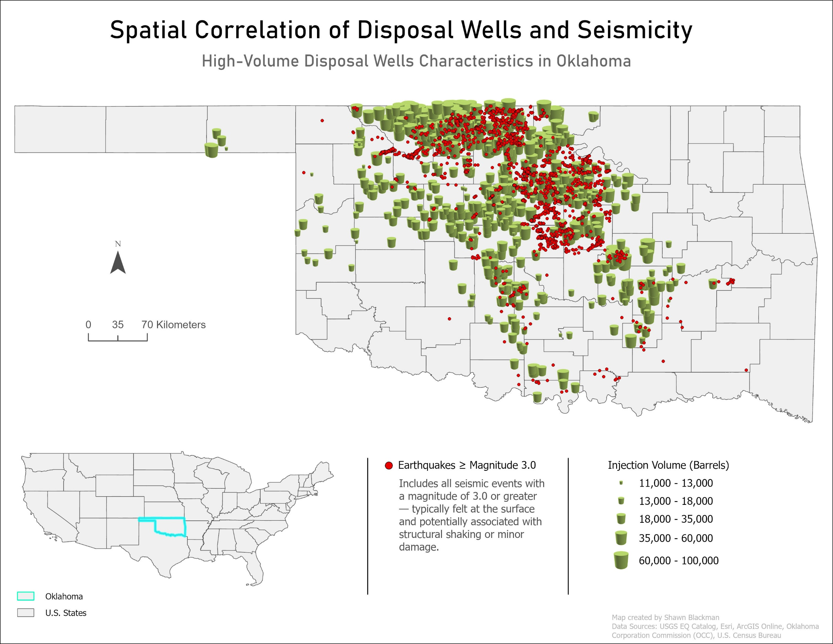

**Figure 4: High Volume Disposal Wells Characteristics in Oklahoma**

The bivariate visualization shows a direct spatial correlation between injection intensity and seismic hazard. The largest graduated symbols, representing maximum volume, cluster directly beneath the densest field of M≥3.0 earthquakes. This supports the conclusion that injection depth relative to the crystalline basement is the strongest predictor of seismic moment release, making volume and depth restrictions critical mitigation strategies (Hincks et al., 2018; Pollyea et al., 2019). The map effectively pinpoints the most probable causal centers of Oklahoma’s seismic crisis, linking operational inputs (volume and pressure) to earthquake outcomes.

**3.3 Quantitative Assessment of Proximity Risk (Ohio and Oklahoma)**

**Table 1: Earthquake Comparison Matrix: Ohio vs Oklahoma**

|  |  |  |  |  |  |  |  |
| --- | --- | --- | --- | --- | --- | --- | --- |
| **Category** | **Buffer** | **Ohio Count** | **Ohio Mag** | **Ohio Depth** | **Oklahoma Count** | **OK Mag** | **OK Depth** |
| **Local** | **5 km** | **1,057** | **2.79** | **5.43** | **6,435** | **2.81** | **5.67** |
|  | **15 km** | **1,379** | **2.79** | **5.45** | **8,304** | **2.81** | **5.71** |
|  | **25 km** | **1,380** | **2.79** | **5.45** | **8,314** | **2.81** | **5.71** |
|  | **45 km** | **1,380** | **2.79** | **5.45** | **8,318** | **2.81** | **5.71** |
| **BodyWave** | **5 km** | **55** | **2.83** | **5.12** | **420** | **2.82** | **5.16** |
|  | **15 km** | **74** | **2.83** | **5.14** | **559** | **2.83** | **5.27** |
|  | **25 km** | **74** | **2.83** | **5.14** | **561** | **2.83** | **5.27** |
|  | **45 km** | **74** | **2.83** | **5.14** | **563** | **2.83** | **5.27** |
| **Moderate ()** | **5 km** | **267** | **3.26** | **5.38** | **2,331** | **3.27** | **5.61** |
|  | **15 km** | **343** | **3.26** | **5.41** | **2,988** | **3.27** | **5.69** |
|  | **25 km** | **343** | **3.26** | **5.41** | **2,991** | **3.27** | **5.69** |
|  | **45 km** | **343** | **3.26** | **5.41** | **2,994** | **3.27** | **5.69** |
| **Strong ()** | **5 km** | **6** | **4.26** | **5.27** | **73** | **4.28** | **5.43** |
|  | **15 km** | **8** | **4.26** | **5.31** | **99** | **4.27** | **5.65** |
|  | **25 km** | **8** | **4.26** | **5.31** | **99** | **4.27** | **5.65** |
|  | **45 km** | **8** | **4.26** | **5.31** | **100** | **4.26** | **5.64** |
| **Shallow (<5 km)** | **5 km** | **482** | **2.84** | **3.79** | **1,955** | **2.85** | **3.80** |
|  | **15 km** | **606** | **2.84** | **3.79** | **2,400** | **2.84** | **3.79** |
|  | **25 km** | **606** | **2.84** | **3.79** | **2,404** | **2.84** | **3.79** |
|  | **45 km** | **606** | **2.84** | **3.79** | **2,406** | **2.84** | **3.79** |
| **Intermediate (5–15 km)** | **5 km** | **567** | **2.85** | **6.18** | **5,388** | **2.86** | **6.20** |
|  | **15 km** | **773** | **2.85** | **6.20** | **7,084** | **2.86** | **6.22** |
|  | **25 km** | **774** | **2.85** | **6.20** | **7,091** | **2.86** | **6.22** |
|  | **45 km** | **774** | **2.85** | **6.20** | **7,097** | **2.86** | **6.22** |
| **Deep (>15 km)** | **5 km** | **3** | **2.91** | **21.33** | **17** | **2.95** | **21.45** |
|  | **15 km** | **4** | **2.89** | **21.20** | **27** | **2.87** | **21.13** |
|  | **25 km** | **4** | **2.89** | **21.20** | **29** | **2.85** | **21.21** |
|  | **45 km** | **4** | **2.89** | **21.20** | **29** | **2.85** | **21.21** |

The buffer analysis quantified how earthquakes cluster around disposal wells, revealing important differences between the two states. **Table 1** summarizes earthquake frequency, average magnitude, and depth across buffer zones for Ohio, demonstrating clear proximity-based patterns.

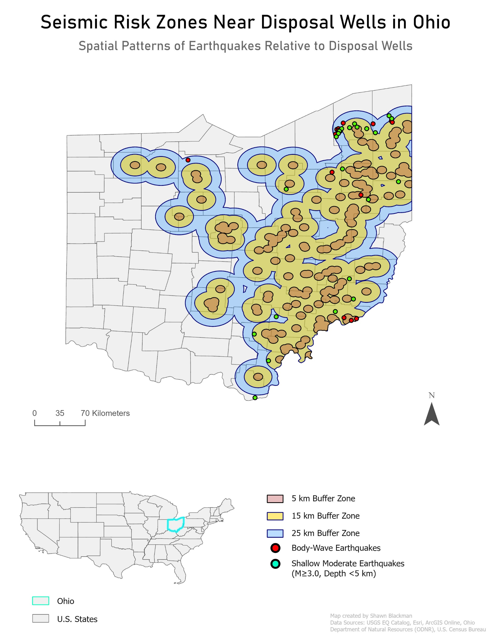

**Figure 5: Seismic Risk Zones Near Disposal Wells in Ohio**

* **Ohio’s Localized Triggering:** Ohio's map confirms the localized hazard. As shown in **Table 1**, 77% of M≥3.0 earthquakes occur within 15 km of disposal wells. Buffer zones at 5 km, 15 km, and 25 km trace the eastern border where wells are concentrated. This underscores the need for proactive, site‑specific regulation in Ohio (Zhou et al., 2024).
* **Depth Consistency:** **Table 1** reveals similar geological influences in both states. Shallow earthquakes (<5 km) consistently average 3.79 km within the 5 km buffer, with focal depths remaining stable across all buffer distances.This places most induced seismicity within the brittle crystalline basement, highlighting its universal susceptibility to injection‑related pressure changes (Pollyea et al., 2019; Kim, 2013).

**3.4 Overlap with Social Vulnerability**

The final maps addressed the central research question by overlaying seismic hazard layers with the Social Vulnerability Index (SVI), normalized by Census Tract, to show where risks overlap with vulnerable populations.

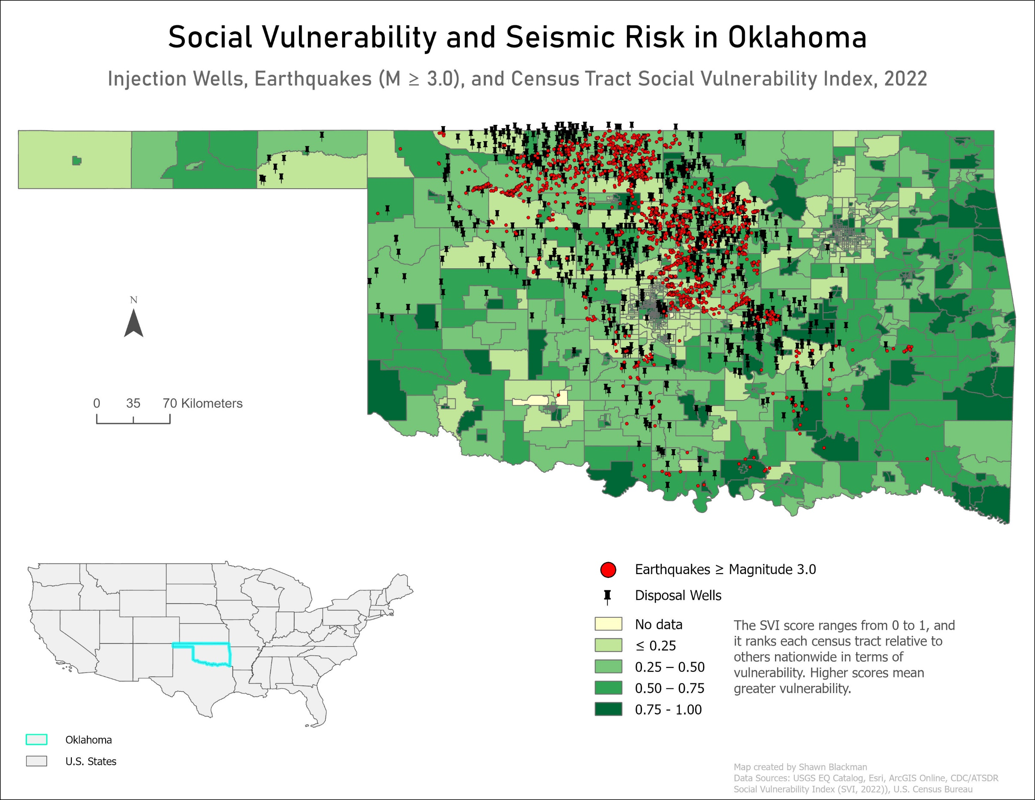

**Figure 6: Social Vulnerability and Seismic Risk in Oklahoma**

**Oklahoma Vulnerability**

* Using a sequential green color scheme, the darkest tracts (0.75–1.00) represent the highest vulnerability. The concentration of M≥3.0 earthquakes and disposal wells in central and north‑central Oklahoma coincides directly with these vulnerable areas.

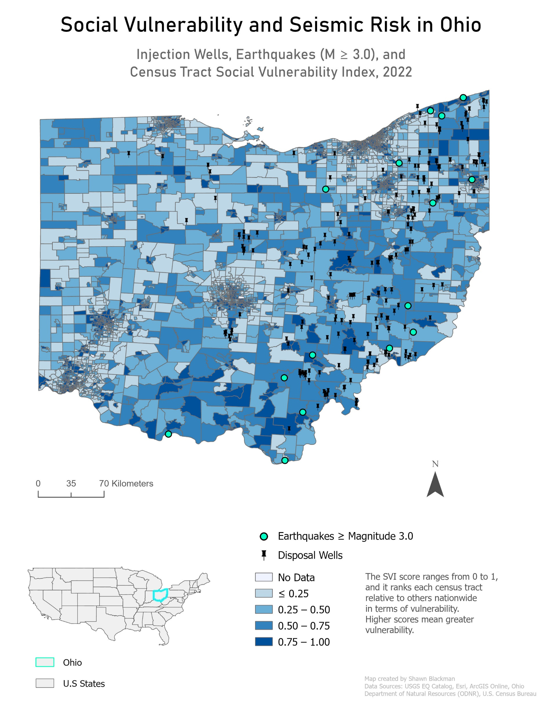

**Figure 7: Social Vulnerability and Seismic Risk in Ohio**

**Ohio Vulnerability**

* A sequential blue color scheme shows SVI values. Earthquake and well clusters along the eastern edge overlap with tracts scoring 0.75–1.00. Although the frequency of events is lower than in Oklahoma, their proximity to vulnerable communities increases local risk.

Both maps confirm that seismic hazards disproportionately affect vulnerable populations, reinforcing the need for targeted mitigation and planning.

**3.5 Regulatory Efficacy and Mitigation Strategies**

The effectiveness of mitigation strategies differs between the two states, reflecting their distinct hazard profiles.

* **Oklahoma’s Engineered Mitigation:** The Oklahoma Corporation Commission’s regulatory response after 2015 was validated by scientific studies. Reducing injection rates and requiring “plug‑backs” (cementing wells to restrict injection depth above the crystalline basement) proved effective in lowering earthquake rates (Skoumal et al., 2024). Mandates restricting injection depths to 200–500 m above the basement could reduce annual seismic moment release by 1.4 to 2.8 times (Hincks et al., 2018).
* **Ohio’s Preventative Strategy:** Ohio adopted a proactive model following the Youngstown crisis (Zhou et al., 2024). The Ohio Department of Natural Resources (ODNR) prohibited Class II disposal wells from penetrating the Precambrian crystalline basement (ODNR, n.d.). Ongoing mitigation relies on strict pre‑permit evaluations and real‑time monitoring through the Ohio Seismic Network (OhioSeis), with immediate operational control enforced via Traffic Light System (TLS) principles (Zhou et al., 2024).

**Conclusions**

The comparative geospatial study of induced seismicity in Oklahoma and Ohio confirmed that the environmental hazard—specifically the clustering of earthquakes of magnitude M≥3.0 near disposal wells—presents a significant and troubling overlap with socially vulnerable populations. The essential distinction between the two crises lies in both scale and the mechanism of pressure transmission. Oklahoma’s hazard is basin‑wide and volumetric, driven by direct hydraulic connectivity with the crystalline basement (Keranen et al., 2014), whereas Ohio’s hazard is highly localized, reflecting near‑field pore pressure diffusion (Kim, 2013). These findings underscore the urgent need for regulatory frameworks tailored to regional geophysical conditions, requiring engineered mitigation strategies such as restricting injection depths to avoid interaction with the seismogenic basement (Hincks et al., 2018).

The project achieved its primary objective of mapping seismic hazards and producing comparable spatial metrics. The analysis validated that EQ_Permanent datasets, when filtered by depth and magnitude, are reliable indicators of proximity‑based seismic risk. The intended audience—federal and state geological and emergency management agencies—can apply the SVI overlap maps and the quantitative matrix to direct preparedness and mitigation resources toward communities most at risk.

Looking ahead, future research should expand the geospatial models by incorporating temporal analysis. Specifically, time‑series data on injection pressure (psi) and volume (bbls) should be examined to determine how fluctuations correlate with the initiation and decline of seismic sequences across buffer zones. Additionally, the models should integrate the complexity of poroelastic stress mechanisms, which are particularly evident in Texas, to create standardized approaches for assessing risk at all high‑volume disposal sites (Zhai et al., 2021).

**References**

Allison, E. (2014, July 16). EPA regulation of induced seismicity and injection wells. *AAPG*.

Cochran, E. S., Rubinstein, J. L., Barbour, A. J., & Kaven, J. O. (2024). *Induced seismicity strategic vision* (Circular 1509). U.S. Geological Survey. https://doi.org/10.3133/cir1509

Disposal wells analysis. (n.d.). *Excerpts from Analysis changed from injection to disposal wells.pdf* .

Ellsworth, W. L. (2013). Injection-induced earthquakes. *Science, 341*(6142). https://doi.org/10.1126/science.1225942

Hincks, T., Aspinall, W., Cooke, R., & Gernon, T. (2018). Oklahoma’s induced seismicity strongly linked to wastewater injection depth. *Science, 359*(6381), 1251–1255. https://doi.org/10.1126/science.aap7911

Jones, A. C., & Rowan, L. R. (2023, January 13). *Earthquakes induced by underground fluid injection and the federal role in mitigation* (CRS Report R47386). Congressional Research Service.

Keranen, K. M., Weingarten, M., Abers, G. A., Bekins, B. A., & Ge, S. (2014). Sharp increase in central Oklahoma seismicity since 2008 induced by massive wastewater injection. *Science, 345*(6195), 448–451. https://doi.org/10.1126/science.1255802

Kim, W.-Y. (2013). Induced seismicity associated with fluid injection into a deep well in Youngstown, Ohio. *Journal of Geophysical Research: Solid Earth, 118*(7), 3506–3518. https://doi.org/10.1002/jgrb.50247

Ohio Department of Natural Resources. (n.d.). How does the regulation of Class II disposal wells help to prevent contamination of ground water? https://ohiodnr.gov

Pollyea, R. M., Chapman, M. C., Jayne, R. S., & Wu, H. (2019). High density oilfield wastewater disposal causes deeper, stronger, and more persistent earthquakes. *Nature Communications, 10*(1), Article 3077. https://doi.org/10.1038/s41467-019-11055-y

Railroad Commission of Texas. (2023, September). *Update: Regulation of disposal wells in seismically active areas of Texas*.

Schultz, R., Skoumal, R. J., Brudzinski, M. R., Eaton, D., Baptie, B., & Ellsworth, W. (2020). Hydraulic fracturing-induced seismicity. *Reviews of Geophysics, 58*(3), e2019RG000695. https://doi.org/10.1029/2019RG000695

Skoumal, R. J., Kaven, J. O., Barbour, A. J., Wicks, C., Brudzinski, M. R., Cochran, E. S., & Rubinstein, J. L. (2021). The induced Mw 5.0 March 2020 west Texas seismic sequence. *Journal of Geophysical Research: Solid Earth, 126*(1), e2020JB020693. https://doi.org/10.1029/2020JB020693

Skoumal, R. J., Kaven, J. O., & Walter, J. I. (2019). Characterizing seismogenic fault structures in Oklahoma using a relocated template-matched catalog. *Seismological Research Letters, 90*(4), 1535–1543. https://doi.org/10.1785/0220180408

Skoumal, R. J., Kaven, J. O., & Walter, J. I. (2024). Plugged wells and reduced injection lower induced earthquake rates in Oklahoma. *The Seismic Record, 4*(4), 279–289. https://doi.org/10.1785/0320240025

Weingarten, M., Ge, S., Godt, J. W., Bekins, B. A., & Rubinstein, J. L. (2015). High-rate injection is associated with the increase in U.S. mid-continent seismicity. *Science, 348*(6241), 1336–1340. https://doi.org/10.1126/science.aab1345

Zang, A., Oye, V., Jousset, P., Deichmann, N., Gritto, R., McGarr, A., Majer, E., & Bruhn, D. (2014). Analysis of induced seismicity in geothermal reservoirs—An overview. *Geothermics, 52*, 6–21. https://doi.org/10.1016/j.geothermics.2014.06.002

Zhai, G., Shirzaei, M., & Manga, M. (2021). Widespread deep seismicity in the Delaware Basin, Texas, is mainly driven by shallow wastewater injection. *Proceedings of the National Academy of Sciences, 118*(20), e2102338118. https://doi.org/10.1073/pnas.2102338118

Zhou, W., Lanza, F., Grigoratos, I., Schultz, R., Cousse, J., Trutnevyte, E., Muntendam-Bos, A., & Wiemer, S. (2024). Managing induced seismicity risks from enhanced geothermal systems: A good practice guideline. *Reviews of Geophysics, 62*(4), e2024RG000849. https://doi.org/10.1029/2024RG000849

**APPENDICES**

Appendix A: Technical GIS Workflow

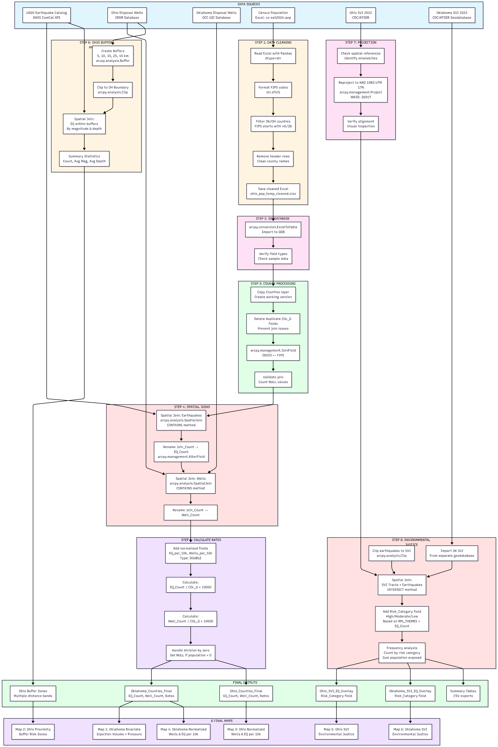

Appendix B: Map Production Workflow

